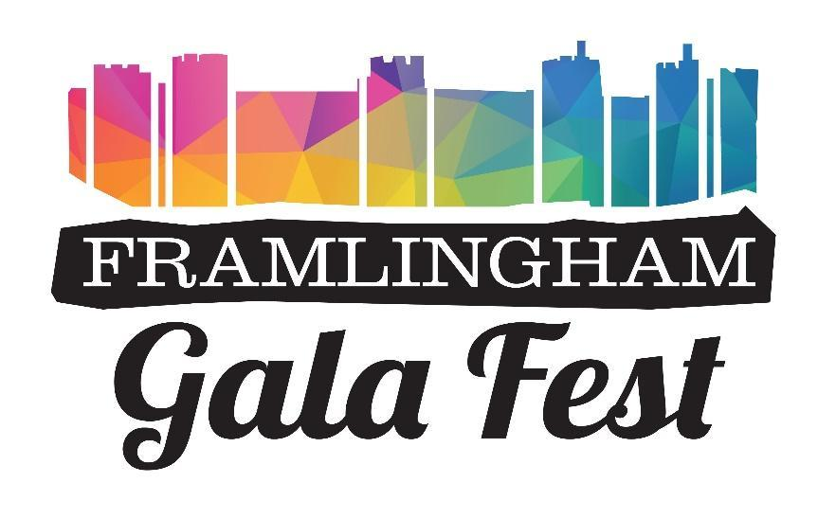
Trade Stands Booking Form
Saturday 23rd May 2026 – Sports Club IP13 9HS
Monday 25th May 2026 – Castle Meadow IP13 9BP

Name _________________________ Framlingham Sports Club
Company _________________________ Badingham Road
Contact Details name _________________________ Framlingham
Contact number& E mail _________________________ IP13 9HS
Please provide brief details of your food/drink/products/items
__________________________________________________________________

Please state the size of your stand____________________________________
Basic cost of stand and size is 3M x 3M £80.00
Food/drink outlets £120.00 .
Electric 16a supply is an additional £30 Yes No
Please state what Appliance/s are being used on the supply and wattage and amps
.................................................................... Wattage ...... Amps .......
Stand for Saturday Yes No
Stand for Monday Yes No
Do you have Public Liability? Yes No
Food Hygiene Certificate? Yes No
Please return certificates with completed booking form to: framgalatradestands@gmail.com or post to Wendy Hayward, Serendipity 4 Pulham Court Mount Pleasant Framlingham IP13 9HQ.
Invoice will be issued on receipt of the booking form.

Terms and Conditions.
Please arrive and set up between 7am and 10am. Vehicles must be off site and in designated parking from 10 am. No vehicle movement until the event has finished at 6pm Please leave your space tidy and clean, take your rubbish home or put it in the bins provided.
Cancellation: Any cancellations made after the 10th April will not be refunded unless there are exceptional circumstances.

I agree with the Terms and Conditions

Signed

Dated

